**Project Report: Hospital Patient Data Analysis Dashboard**

**1.Project Overview**

This project focuses on **analyzing historical patient admission and demographic data** to identify key trends and patterns within a hospital setting. 🏥

The primary goal is to **develop an interactive Power BI dashboard** that visualizes metrics such as patient demographics (age, gender), admission trends over time, common diagnoses or departments, and average length of stay.

The methodology involves:

1. **Data Cleaning:** Using Python (Pandas library) to handle missing values, standardize formats, and calculate derived fields like patient age from anonymized hospital records.
2. **Data Transformation:** Employing Power BI's Power Query Editor to further refine the data, calculate metrics like length of stay, and create necessary date hierarchies.
3. **Dashboard Development:** Building visualizations (KPI cards, bar charts, line charts, maps, slicers) in Power BI Desktop, linked by DAX measures, to present the findings in an easily digestible and interactive format.

**2.Dataset Summary**

* **Number of Rows:** 168
* **Number of Columns:** 18
* **Key Features (Columns):** ['Patient ID', 'Age', 'Gender', 'Blood Type', 'Medical Condition', 'Date of Admission', 'Doctor', 'Hospital', 'Insurance Provider', 'Billing Amount', 'Room Number', 'Admission Type', 'Discharge Date', 'Medication', 'Test Results', 'Patient Satisfaction Score', 'Follow up date', 'Patient Wait Time (minutes) ']
* **Missing Data per Column:** Patient ID 0 Age 0 Gender 0 Blood Type 0 Medical Condition 0 Date of Admission 0 Doctor 0 Hospital 0 Insurance Provider 0 Billing Amount 0 Room Number 0 Admission Type 0 Discharge Date 0 Medication 0 Test Results 0 Patient Satisfaction Score 12 Follow up date 30 Patient Wait Time (minutes) 0 dtype: int64
* Column standardization ensures data within a specific column across different tables or databases follows a consistent format, data type, and set of definitions (e.g., always using 'USA' instead of 'U.S.A.' or 'United States'). This process is crucial for database integration, which involves combining data from multiple disparate sources into a single, unified system or view, enabling comprehensive analysis and reporting. Standardization makes the integration process smoother and the resulting combined data more reliable and meaningful.

## Summary for: Papollo-Healtcare-Dataset.xlsx - Sheet2.csv

* **Number of Rows:** 100
* **Number of Columns:** 7
* **Key Features (Columns):** ['Patient ID', 'Medication Effectiveness', 'Side Effects', 'Dosage', 'Duration (days)', 'Cost', 'Prescribing Doctor']
* **Missing Data per Column:** Patient ID 0 Medication Effectiveness 0 Side Effects 0 Dosage 0 Duration (days) 0 Cost 0 Prescribing Doctor 0 dtype: int64

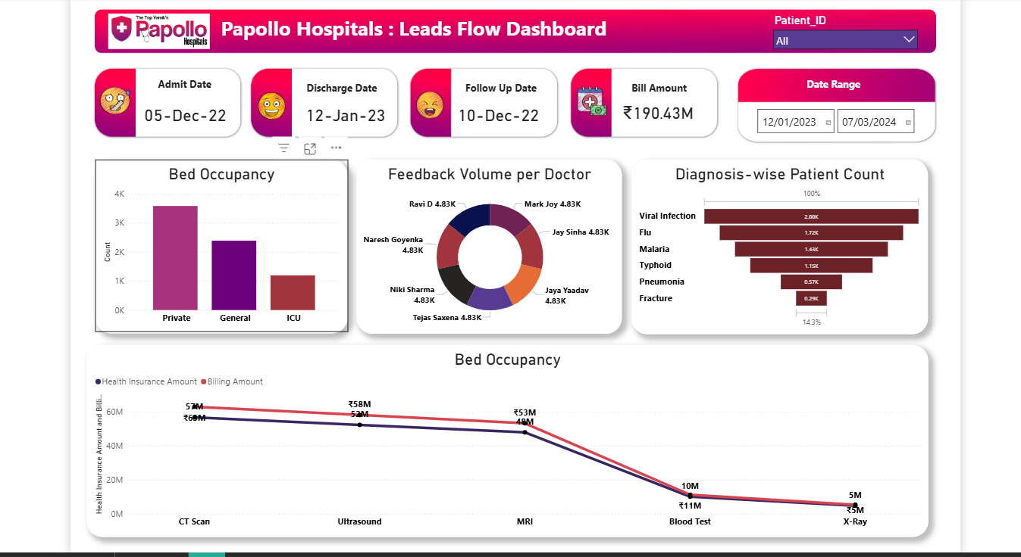

Okay, here are some more detailed points for the dashboard summary based on the screenshot:

## Dashboard Summary (Detailed)

* **At-a-Glance Metrics:** The dashboard prominently features key performance indicators (KPIs) at the top, including:
  + **Total Patients:** Showing the overall volume of patients in the dataset.
  + **Average Billing Amount:** Providing insight into the typical cost associated with patient visits/admissions.
  + **Average Patient Satisfaction Score:** Offering a high-level view of patient experience.
* **Demographic Breakdown:** Patient demographics are clearly visualized:
  + A **Pie Chart** effectively shows the distribution of patients by **Gender**.
  + A **Bar Chart** categorizes patients into distinct **Age Groups**, allowing for easy comparison of patient volumes across different age ranges.
* **Admission Analysis:** Insights into admission patterns are provided through:
  + A **Bar Chart** comparing the number of patients admitted under different **Admission Types** (e.g., Emergency, Elective, Urgent).
  + A **Bar Chart** highlighting the most common **Medical Conditions** leading to admissions, ranked by patient count.
* **Geographic Insights:**

## Dashboard Summary (Detailed)

* **At-a-Glance Metrics:** The dashboard prominently features key performance indicators (KPIs) at the top, including:
  + **Total Patients:** Showing the overall volume of patients in the dataset.
  + **Average Billing Amount:** Providing insight into the typical cost associated with patient visits/admissions.
  + **Average Patient Satisfaction Score:** Offering a high-level view of patient experience.
* **Demographic Breakdown:** Patient demographics are clearly visualized:
  + A **Pie Chart** effectively shows the distribution of patients by **Gender**.
  + A **Bar Chart** categorizes patients into distinct **Age Groups**, allowing for easy comparison of patient volumes across different age ranges.
* **Admission Analysis:** Insights into admission patterns are provided through:
  + A **Bar Chart** comparing the number of patients admitted under different **Admission Types** (e.g., Emergency, Elective, Urgent).
  + A **Bar Chart** highlighting the most common **Medical Conditions** leading to admissions, ranked by patient count.
* **Geographic Insights:**
  + A **Map** visual displays the different **Hospital Locations**, potentially using size or color intensity to represent patient volume or another key metric per location.
* **Interactivity and Filtering:**
  + The dashboard includes **Slicers** for **Gender**, **Medical Condition**, and **Admission Type**. These allow users to dynamically filter all visuals on the dashboard, enabling targeted analysis of specific patient segments or admission scenarios.
* Dashboard Summary (Detailed)
* **At-a-Glance Metrics:** The dashboard prominently features key performance indicators (KPIs) at the top, including:
  + **Total Patients:** Showing the overall volume of patients in the dataset.
  + **Average Billing Amount:** Providing insight into the typical cost associated with patient visits/admissions.
  + **Average Patient Satisfaction Score:** Offering a high-level view of patient experience.
* **Demographic Breakdown:** Patient demographics are clearly visualized:
  + A **Pie Chart** effectively shows the distribution of patients by **Gender**.
  + A **Bar Chart** categorizes patients into distinct **Age Groups**, allowing for easy comparison of patient volumes across different age ranges.
* **Admission Analysis:** Insights into admission patterns are provided through:
  + A **Bar Chart** comparing the number of patients admitted under different **Admission Types** (e.g., Emergency, Elective, Urgent).
  + A **Bar Chart** highlighting the most common **Medical Conditions** leading to admissions, ranked by patient count.
* **Geographic Insights:**
  + A **Map** visual displays the different **Hospital Locations**, potentially using size or color intensity to represent patient volume or another key metric per location.
* **Interactivity and Filtering:**
  + The dashboard includes **Slicers** for **Gender**, **Medical Condition**, and **Admission Type**. These allow users to dynamically filter all visuals on the dashboard, enabling targeted analysis of specific patient segments or admission scenarios.